The Biomechanics of Illegal Bowling Actions in Cricket

Dr Rene E. D. Ferdinands

Abstract
There is little doubt the action of bowling in cricket is unique in its scope and execution. Whereas the natural inclination is to flex, extend and internally rotate the arm to project an object with speed and accuracy, the law of bowling requires this same task to be performed with a rigid arm. It has been argued that the natural method, which is ‘throwing’ according to the classical definition, is a product of our evolutionary past, presumably used by our ancestors to impart a cruel blow or even hurl objects at prey (having a higher level of sophistication our ancesters did not just fight against each other, right?) with malicious intent. However, the idea of hurling objects with speed with a straight arm is a more recent idea. One that is exclusively practised by those most hardened of athletes – cricketers! Intuitively it is almost impossible to conceive how such a method can be used to project a red spherical leather object at a batter with various concoctions of spin, swerve and speed. However, all is not what it seems! This history of bowling has been punctuated with the severest of allegations that can be directed at a bowler – that of being a “thrower”, or more derogatorily, a “chucker!” One such period was in the 1960s, with quality bowlers cited for throwing such as Tony Lock (England), Charlie Griffith (West Indies), and most famously Ian Meckiff (Australia), who was no-balled out of the game in 1963. Confusion reigned as to what actually constituted a legal bowling delivery. Today, cricket faces another such turbulent period with prominent bowlers such as Brett Lee (Australia), Shoaib Akhtar (Pakistan), Harbajhan Singh (India), and Muttiah Muralitharan (Sri Lanka) all of whom have been at one time been cited for throwing. Despite the technological advances in high speed cameras, even more confusion surrounds this issue than before. However, the most comprehensive biomechanics research in this field suggests new concepts to redefine the bowling law.

The Bowling Law Problem
Originally bowling in cricket was performed as an under-arm motion (i.e. under waist height). A ball was deemed illegal when the elbow was higher than the level of the hand during delivery:
1829: Law 10 – The ball shall be bowled. If it be thrown or jerked, or if any part of the hand or arm be above the elbow at the time of delivery, the umpire shall call “No Ball.”
Despite much opposition, many bowlers were unsatisfied with this means of delivery, and experimented with a more horizontal trajectory of the bowling arm, which came to be known as ‘round-arm’ bowling. Officially, round-arm bowling was legalised in 1835 MCC code, and bowlers were allowed to raise their arms to shoulder height level. However, the evolution of the bowling arm trajectory was to continue towards the vertical with bowlers now raising the bowling arm higher leaving many batsmen confounded, some of whom complained bitterly. Despite the heated controversy, common sense prevailed, and the over-arm action was legalised in the 1884 MCC code:
1884: Law 26 – “For a delivery to be fair the ball must be bowled, not thrown or jerked.”
Over-arm bowling became an art of infinite subtlety, not only in strategy, but also in its most basic mechanics. Always in their endeavour to have one over the batter, bowlers were quickly developing an impressive arsenal of skills – from varying the pace, the length (the distance travelled before bouncing), and the line of delivery, to swinging, spinning and swerving: motions dependent on the intricate combination of the seam angle and spin of the ball as it travels through the air. Despite the obvious merits of over-arm motion, the 1884 MCC law, though explicitly against throwing, made no attempt to define the mechanical properties of a throw as opposed to a bowl. The matter was left largely up to the subjective impression of the umpires, and it should have been of little surprise that any call of no-ball for a thrown delivery was followed with controversy and strong emotion.
The period from the early 1950s to the mid-1960s, apart from some brilliant cricket, was known for some notable calls of throwing. Tony Lock (England) had been called for throwing in first-class cricket, and it was reported that he had to modify his action several times to satisfy the umpires. Suspicion was raised on the action of Charlie Griffith (West Indies) – that he threw the ball during unpredictable spells of express pace bowling. However, arguably the most famous incident of all was the calling of Australia’s Ian Meckiff by Colin Eagar during the First Test against South Africa in Brisbane (Figure 1). This dramatic event was reported around the world, and sadly culminated in Ian Meckiff’s retirement from the game. He had decided against continuing his career with a modified action to satisfy the 2nd edition of the1947 MCC code:
1947 code (2nd Edition, 1952): Law 26-“For a delivery to be fair the ball must be bowled, not thrown or jerked; if either Umpire be not entirely satisfied of the absolute fairness of a delivery in this respect, he shall call and signal “Not Ball” instantly upon delivery.”
The law is very clear on the umpire’s role in calling a bowler for throwing if he is not entirely satisfied with the fairness of the delivery. In other words, if in doubt the umpire is to call ‘no-ball!’. However, Law 26 (1947 code) was no different from the corresponding law in 1884 in that it does not define the mechanical constituents of a ‘throw’. Even more mysterious is the term ‘jerk’ which had no definition and could therefore mean any one of a multitude of things. The whole issue was left up to the subjective impression of the umpires without the slightest aid to the umpires. It should therefore not be surprising that during the time of Ian Meckiff there was no tangible framework from which to resolve the speculation and confusion surrounding the growing throwing controversy cricket.
To help resolve this problem, an attempt was made to define a throw as the straightening of the elbow immediately prior to delivery. This concept was officially accepted in the 4th edition of 1947 MCC code in 1970:
1947 code (4th Edition, 1970): Law 26b – A ball shall be deemed to have been thrown if, in the opinion of either umpire, the process of straightening the bowling arm, whether it be partial or complete, takes place during that part of the delivery swing which directly precedes the ball leading the hand. This definition shall not debar a bowler from the use of the wrist in the delivery swing.
This was a significant improvement on the previous bowling laws in that throwing was now defined if there was violation of an anatomical and temporal biomechanical constraint: elbow extension (anatomical constraint) was not permitted just prior to release (temporal constraint). However, there had been no biomechanical testing to evaluate whether bowlers could in fact satisfy this law. Also, the temporal constraint of “directly precedes release” was not well understood.
After the calling of Ian Meckiff, the issue of throwing was not prominent in the minds of the cricket administrators until the controversial calling of Muttiah Muralitharan (Sri Lanka) from the bowler’s end by umpire Darrel Hair at the Melbourne Cricket in 1995. In response to this incident, bowling legality became a matter of biomechanics. Muttiah Muralitharan was subjected to clinical examinations, electrogoniometer angle measurements, and three-dimensional motion analysis of his bowling arm. The tests revealed that Muttiah Muralitharan had a fixed flexion deformity of his bowling elbow (Lloyd, 2000). Hence, the perception of his elbow angle changes depending on the observer’s perspective. This confirmed that observations by the naked eye could not be relied upon to give an accurate assessment of changes in elbow angle during bowling (Goonetilleke, 1999). It also confirmed the need for three-dimensional biomechanics testing, and showed that the determination of legality in bowling needs to consider anatomical, physiological, and mechanical factors. It was also suggested that the 1947 code (4th edition) was not specific in its description ‘directly precedes the ball leading the hand’ (Lloyd, 2000). This may have prompted the issuing of the 2000 MCC code:
2000 code: Law 24.3 - A ball is fairly delivered in respect of the arm if, once the bowler's arm has reached the level of the shoulder in the delivery swing, the elbow joint is not straightened partially or completely from that point until the ball has left the hand. This definition shall not debar a bowler from flexing or rotating the wrist in the delivery swing.
However, from this point onwards, the throwing controversy only heightened with other prominent bowlers cited for throwing: Brett Lee (Australia), Shoaib Akhtar (Pakistan), and Harbajhan Singh (India). Also, Saqlain Mustaq (Pakistan) invented a new ball called the ‘doosra’, which is the finger-spinners version of the googly. A few years later both Harbajhan Singh and Muttiah Muralitharan had mastered this delivery. Muralitharan’s doosra was the most effective, and elite batsmen throughout suffered some embarrassing dismissals. Then the doosra itself came under the scrutiny of players and administrators, and it was claimed impossible to bowl the doosra without throwing it. In particular, Muralitharan’s doosra was targeted, and he subject to further testing.
At about this time it became more commonly known that there was a modification to the anatomical constraint imposed by Law 24.3 in the 2000 MCC code: that the bowling arm not straighten from shoulder height to ball release. Instead the ICC had now specified an acceptable range of elbow extension tolerance levels, which were dependent on ball release speed. Fast bowlers were allowed 10° elbow extension, medium pace bowlers 7.5°, and spin bowlers only 5° (Elliott et al., 2004).
At the University of Western Australia (Department of Human Movement and Exercise Science), three-dimensional kinematic measurements of Muttiah Muralitharan’s bowling arm were taken using high speed cameras while he bowled his doosra. Murali’s mean elbow extension angle for the doosra delivery was 14°, which was subsequently reduced to a mean of 10.2º with a modified action. Though Elliott et al. (2004) concluded that “Mr. Muralitharan be permitted to continue bowling his doosra at least until a valid data base is collected on the various spin bowling disciplines”, the overwhelming response was that Murali’s doosra contravened the established ICC elbow extension limit of 5º for spinners.
The issue of throwing in this decade, however, does not stop with Murali. The two fastest bowlers in the world Shoaib Akhtar (Pakistan) and Brett Lee (Australia) have both been called for throwing. Shoaib was also required to undergo laboratory testing at the University of Western Australia, where it was concluded that he had a hyperextension abnormality which prevented him from bowling with a straight arm. Brett was subject to a hearing, which included a select panel of experts from each of the ICC test playing countries. At the end of the hearing it was concluded that according to the evidence presented there was no basis to find fault with his action. Unfortunately, the evidence did not include a three-dimensional kinematic analysis of his bowling, which Muttiah Muralitharan, Shoaib Akhtar, and more recently Shoaib Malik were all subject to.
With the two fastest bowlers in the world having been reported for suspect actions, the clinical presence of elbow abnormalities in some bowlers, the possibility of higher levels of elbow laxity in bowlers from Asia, the invention of the doosra, and the technology of high speed cameras; it seems that the determination of the bowling law in cricket is far from being resolved. The issue is certainly not clear cut, and there is a real danger of accepting a simplistic and hence unfair solution. The question is: “Could the legality of bowling actions be resolved scientifically or should cricket go back to the old times of relying on the subjective impression of cricketers, administrators, and umpires?”
Problems with the subjective method are that (i) the naked eye, and even the use of normal video footage is not capable of making an accurate determination of bowling legality (Goonetilleke, 1999), (ii) it is often impossible to find consensus except perhaps in the most obvious cases, and (iii) it can be very much subject to bias. On logical grounds, science is the tool that should be at least tried to resolve this matter.
Some of the world’s leading research on elbow angle in cricket bowling is conducted at the University of Waikato (Department of Physics & Electronic Engineering) and the University of Auckland (Biomechanics Laboratory) in New Zealand. They published the first laboratory studies that examined the elbow angle characteristics of bowlers across all speed groups, including spin bowlers. Their research shows that the bowling law in cricket has been largely inadequate in defining what constitutes a fair delivery. In fact, their latest research reveals a new biomechanical property of the elbow angle in bowling, which could be used to define a new bowling law.

Biomechanical Testing Protocol
Sixty-nine bowlers were selected for the study, and grouped into fast, med-fast, medium, slow, and finger-spin categories. Also, 8 bowlers in this sample were observed as possibly having a “throwing-type” or “jerky” action. All the subjects were free from any injury or physical dysfunction, which may have affected bowling performance at the time of data collection sessions. The pace bowlers were instructed to bowl at maximum speed and the spinner to bowl as under match conditions.
Eight Motion Analysis High Resolution cameras with frame rates of 240 Hz were placed around the subject so that the field of view was sufficient to capture the performance area of the trials, which was centred on a running track (Figure 1). The running track passed through the laboratory enabling sufficient distance for the run-up, and delivery of the ball at the wickets a pitch length away.
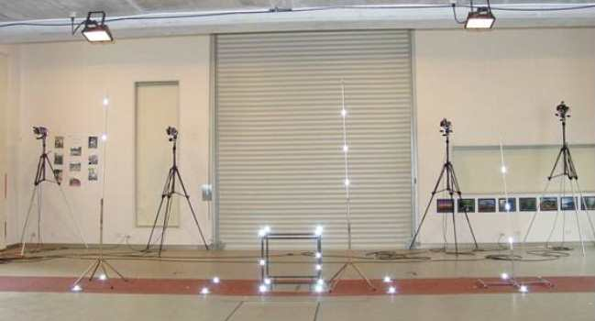
Figure 1: The athletics track runs through the laboratory doors giving sufficient space for run-up and delivery.
To calculate the position of anatomical joint centres, and to reduce the number markers placed on the subject during testing, a static trial calibration marker set, and a bowling trial marker set were used for the bowling arm. The 10-markers used for the static trial set were placed on the following positions: anterior deltoid, posterior deltoid, biceps, triceps, lateral epicondyle of elbow, medial epicondyle of elbow, lateral aspect of wrist, medial aspect of wrist, and two markers on the dorsal surface of the hand (Figure 2).
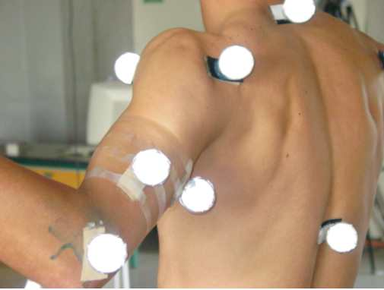
Figure 2: Static marker set for bowling arm.
For the bowling trials, three markers were removed: medial elbow, triceps, and biceps markers. The remaining seven markers in the bowling trial marker set represent the minimum number of markers that can be used to perform a three-dimensional kinematic analysis of the upper arm in this model so that the subject experienced minimal marker impediment during the trials.
The 3D elbow angles were calculated from the relative orientation of the forearm to the upper arm based on the definition of general Euler joint angles (Grood and Suntay, 1983; Ferdinands, 2004). The resulting orthogonal joint coordinate system (JCS) for the upper arm defined the elbow flexion-extension axis as a projection of the vector running through the medial and lateral epicondyles in the plane of and orthogonal to the long axis of the upper arm. The pronation-supination axis was the long axis of the forearm, and the varus-valgus axis was defined as orthogonal to both the flexion-extension and pronation-supination axes, and calculated by means of the cross product. The elbow angle was measured as both the absolute segment angle between the upper am and forearm (elbow segment angle), and the angle about the flexion-extension axis (elbow flexion or extension angle). Six trials per subject were recorded.

The Straight Arm Myth
Until recently, the predominant view in cricket was that legal bowling involved the use of a perfectly straight arm throughout delivery. It was therefore considered a relatively simple matter to detect a bowler who was transgressing this principle: any straightening of the arm prior to release was evidence of throwing. This principle was formally embedded into MCC law 24.3 (2000 code), so that any straightening partial or complete from shoulder height to ball release was prohibited. However, according to this law, every one of the 69 bowlers tested in the sample, 40% of which are test and first-class bowlers, is throwing (Table 1). It would be a reasonable assumption to extrapolate this finding, and state that according to this law almost every bowler in the history of the game has been throwing the ball. Clearly, it is not the bowlers who are at fault, but a law that was formulated without formal biomechanical testing.
Table 1: Percentage of legal bowlers according to MCC Law 24.3 (2000 code).
Fast | Fast/med | Medium | Slow | Spin
0.0% | 0.0% | 0.0% | 0.0% | 0.0%
Two previous studies have also provided evidence that a straight arm throughout the delivery phase is not performed by fast bowlers. In an outdoor fast motion video analysis of fast bowlers, Portus et al. (2003) showed that there could be up to 15º elbow extension during this period. Also, Ferdinands (2004) in his PhD thesis hypothesised from an analysis of forearm joint powers of fast bowlers that it is likely that bending and extension of the bowling arm is a mechanical property of bowling. This was qualitatively supported with pictures of famous fast bowlers with slightly flexed bowling arms at shoulder height.

The Ferdinands and Kersting (2004) Study: Elbow Extension Tolerance Limits
In response to evidence that MCC Law 24.3 did not appropriately define the constituents of a legal bowling action in practice, the ICC suggested a set of tolerance levels for elbow extension angle according to ball release speed: fast bowlers were allowed 10º, medium pace bowlers 7.5º, and slow and spin bowlers only 5º (Elliott et al., 2004). Ferdinands and Kersting (2004) used 8 fast motion cameras (240 HZ) to perform a full 3D laboratory kinematic analysis of 42 bowlers over the full range of bowling speeds, including off-spinners. They found that though the specification of the ICC limits was an improvement over Law 24.3, too many bowlers would be still defined as throwing. Also, the data did not support the implementation of lower elbow extension angle thresholds for the slower bowling groups, and that the 5º limit for slow and spin bowlers was particularly impractical. Ferdinands and Kersting (2004) therefore suggested that a flat rate of 15º tolerable elbow extension be used to define a preliminary demarcation point between bowling and throwing. This is the first published laboratory study that examined elbow extension angle. It must be pointed out that outdoor video measurements have a higher degree of measurement error, and therefore need the support of a laboratory study to establish their validity (Elliott et al., 2004). This study had been formally accepted by the recent ICC summit in Dubai (October 25 and 26, 2004), which discussed the biomechanical evidence relating to the amount of elbow extension in bowling.

Elbow Extension Tolerance Limits: New Study
The first objective of the new study was to validate the preliminary findings of Ferdinands and Kersting (2004) on elbow extension angle tolerance levels. With more subjects (69), and a review of testing protocols, the findings were largely consistent with that of the preliminary study. The sample mean of elbow extension angle for fast bowlers was within the 10º threshold (Table 2). However, the data was variable, and in individual trials certain fast bowlers exceeded the 10º limit. For instance, a first-class fast bowler with a mean elbow extension angle of 9.4º, and who had never been cited for throwing registered the following elbow extension angles: 7.3º, 6.6º, 8.1º, 14.7º, and 10.5º. Similarly, a young fast bowler who had never had any questions raised about the integrity of his action had elbow extension angles of 12.4º, 14.2º, 11.9º, 14.2º, and 12.7º. Yet the most significant problem with the ICC limits is that they are unrealistically stringent on the slow and spin bowling groups (Table 2). An excessive proportion of slow and spin bowlers would be classed as throwers. This occurs because there is no correlation between ball release speed and elbow extension angle for the major bowling groups, and therefore no evidence to support a lower elbow extension angle limit for slow and spin bowlers (Figure 3).
Table 2: Percentage of legal bowlers according to ICC elbow angle tolerance level: Fast (10º), FastMedium and Medium (7.5º), Slow and Spin (5º).
Fast | Fast/med | Medium | Slow | Spin
86.7% | 87.5% | 100.0% | 35.7% | 60.0%
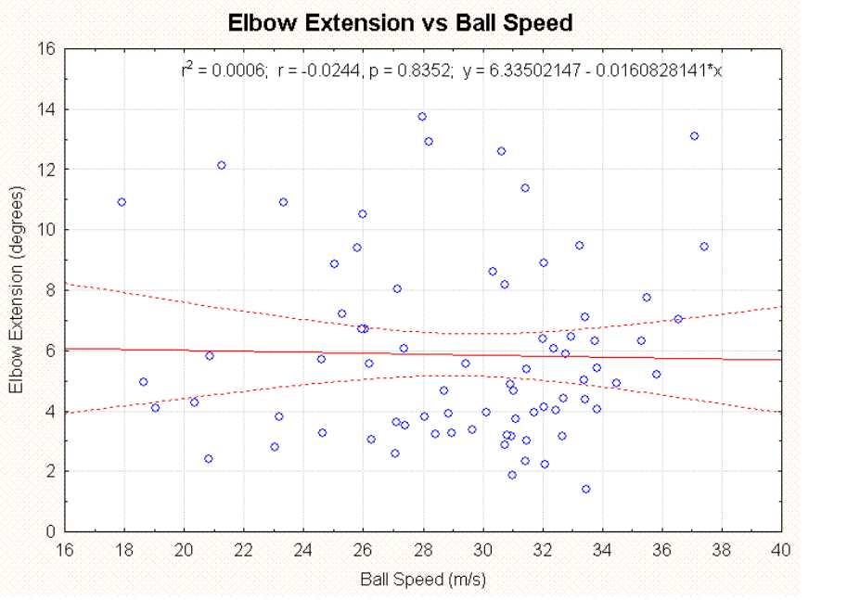
Figure 3: Elbow extension angle shows no correlation with ball speed across the sample.
A box and whisker plot of mean, standard error and standard deviation also shows the variability of both intra- and inter-group elbow extension angle data (Figure 4). For instance, the group with the lowest and most stable elbow extension angle was the medium-pace group. In contrast, the group with the most variability was the spin bowling group. It would be impractical to consider imposing different elbow extension angle limits on each bowling group. Apart from the fact that the sample sizes of each group are not large enough to represent a universal representation of bowling type, such a method would yield an unworkable solution. Two examples would be (i) a medium-pace bowler who consistently varies the pace of delivery throughout the over, and (ii) a bowler who releases the ball at a speed around the border of two neighbouring speed groups, such as the slow and medium group, or the fast and fast medium-group. Therefore, a flat elbow extension angle limit across all bowling groups is the logical solution as first suggested by Ferdinands and Kersting (2004).
By calculating the percentage of legal bowlers under various elbow extension angle limits, it is evident that the percentage of legal bowlers is almost 100% across the bowling groups at 13º (Table 3). If it is assumed that most of the bowlers in the bowling sample (i.e. excluding the throwing group) have legal actions, then an appropriate elbow extension angle limit may be defined somewhere between 13º - 14º for all bowlers, irrespective of bowling type or speed.
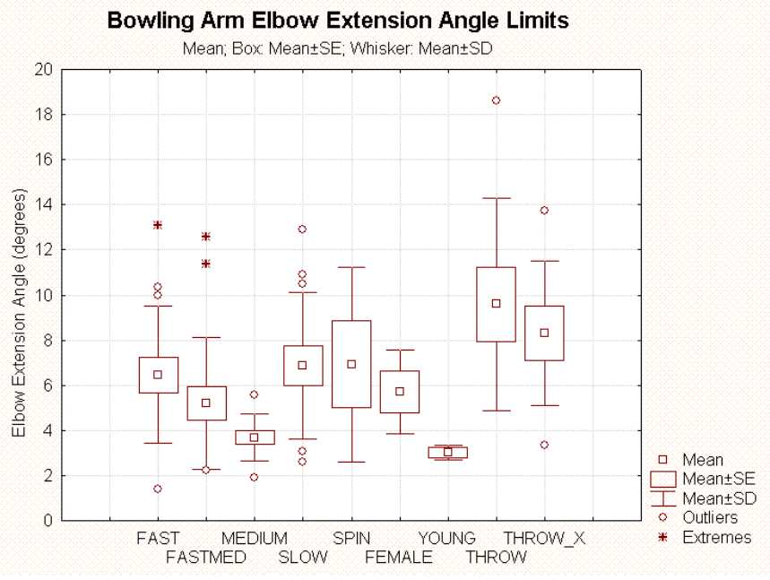
Figure 4: Mean and standard error box plot of bowling arm elbow extension for all bowling groups. THROW_X represents the data from the throwing group excluding the extreme outlier.
Table 3: Percentage of legal bowlers for range of acceptable mean elbow extension angle tolerances.
 | 0º | 5º | 7.5º | 10º | 12º | 13º | 14º | 15º
Fast | 0.0% | 33.3% | 73.3% | 86.7% | 93.3% | 93.3% | 100.0% | 100.0%
Fast/med | 0.0% | 62.5% | 87.5% | 87.5% | 93.8% | 100.0% | 100.0% | 100.0%
Medium | 0.0% | 90.0% | 100.0% | 100.0% | 100.0% | 100.0% | 100.0% | 100.0%
Slow | 0.0% | 35.7% | 64.3% | 78.6% | 92.9% | 100.0% | 100.0% | 100.0%
Spin | 0.0% | 60.0% | 60.0% | 60.0% | 80.0% | 100.0% | 100.0% | 100.0%
Throw | 0.0% | 12.5% | 25.0% | 75.0% | 75.0% | 75.0% | 87.5% | 87.5%

A New Biomechanical Concept: Elbow Angle Slope
The new study also examined bowlers who were either suspected of throwing, or observed to have a “jerkiness” of the bowling action. They were classified in the “throwing” group, even though it had not been proven that were actually transgressing any elbow extension angle limit. The throwing group had a higher mean elbow extension range than the other bowling groups, but not significantly so when the outlier was removed from the dataset, and not beyond the legal range (Figure 4). The outlier represented one subject who had a mean elbow extension angle of 18.6º, and was clearly throwing the ball. However, even at the 10º elbow extension angle limit, 75% of the throwing group were still legal. At the 14º limit, 87% of the throwing group was legal. Hence, the throwing group could not be differentiated from the other bowling groups by elbow extension angle. This suggests that either (i) the bowlers in the throwing group were not generally throwing and the visual effect of jerkiness was an illusion, or that (ii) a throwing-type action is not solely determined by elbow extension angle. If the latter was correct, then another biomechanical concept is needed to differentiate a throw from a bowl.
The 1947 MCC code (4th Edition) defined throwing as either a partial or full extension occurring immediately prior to release. Goonetilleke (1999) showed that Muttiah Muralitharan was bowling legally according to this law. However, there had been no large scale study to determine whether this law could fairly determine bowling action legality. To test this law, the elbow excursion angle slope was calculated as the linear rate of change of elbow angle through release. If the rate of change of elbow angle through release was positive then the elbow extends through release, and the slope is positive. Conversely, if the rate of change of elbow angle is negative, then the elbow flexes through release, and the slope is negative. If the slope is zero, then the bowling arm remains perfectly rigid through release. Slope calculations were preferred to actual angle measurements because (i) biomechanists use cameras at different frame rates, and (ii) it is difficult to determine exactly when the point of ball release occurs. Therefore, the angle through release would depend on what time after ball release the measurement was made. In this study, the slope for all subjects was calculated from two frames before release to two frames after.
Correlating elbow angle slope to Law 26b of the 1947 MCC code (4th Edition), a legal delivery is one that has an elbow angle slope of less than or equal to 0º/s. This law is superior to Law 24.3 of the MCC 200 code, because many bowlers, after an initial period of elbow straightening, many bowlers are able to maintain the elbow angle or slightly flex the elbow through ball release (Table 4). However, the law is not perfect, because significant percentages of bowlers are unable to do this. For example, according to this law 20.0% of the fast bowlers, 25.0% of the fast-medium bowlers, 27.3% of the medium bowlers, 64.3% of the slow bowlers and 20.0% of the spin bowlers would be defined as throwers. These percentages are too high if one assumes that most of the bowlers in the sample were bowling conventionally. This would be particularly true of the faster bowling groups and the spin bowling group because these included the largest proportion of elite subjects.
Of the throwing group, only one of the eight suspected bowlers flexed the elbow through release. Unlike elbow extension angle, elbow angle slope through release was able to differentiate those bowlers in the throwing group from the other bowling groups. By increasing the threshold of allowable elbow angle slope, this property could be used to further differentiate between the throwing group and the bowlers. For a range of elbow angle slope greater than 150º/s, 62.5% of the throwing group would be considered illegal, and high percentages of the bowling groups would be considered legal (Table 4). A box and whisker plot of mean and standard error data suggests that (i) elbow angle slope through release is a more appropriate concept to differentiate throwers from bowlers, and (ii) the cut-off elbow angle value would lie between 150-200º/s (Figure 5).
Table 4: Percentage of bowlers in their respective groups as a function of elbow angle slope (º/s) through release. Less than 0º/s means that the elbow is flexing through release; otherwise it is extending.
 | <0º/s | 0-25º/s | 0-50º/s | 0-100º/s | >0º/s | >100º/s | >150º/s | >200º/s | >250º/s
Fast | 80.0% | 6.7% | 13.3% | 13.3% | 20.0% | 6.7% | 6.7% | 0.0% | 0.0%
Fast/med | 75.0% | 6.3% | 12.5% | 12.5% | 25.0% | 12.5% | 0.0% | 0.0% | 0.0%
Medium | 72.7% | 9.1.% | 18.2% | 18.2% | 27.3% | 9.1% | 0.0% | 0.0% | 0.0%
Slow | 35.7% | 7.1% | 14.3% | 35.7% | 64.3% | 28.6% | 14.3% | 14.3% | 0.0%
Spin | 80.0% | 0.0% | 20.0% | 20.0% | 20.0% | 0.0% | 0.0% | 0.0% | 0.0%
Female | 25.0% | 25.0% | 25.0% | 50.0% | 75.0% | 25.0% | 25.0% | 0.0% | 0.0%
Young | 50.0% | 50.0% | 50.0% | 50.0% | 50.0% | 0.0% | 0.0% | 0.0% | 0.0%
Throw | 12.5% | 12.5% | 12.5% | 12.5% | 87.5% | 75.0% | 62.5% | 50.0% | 37.5%
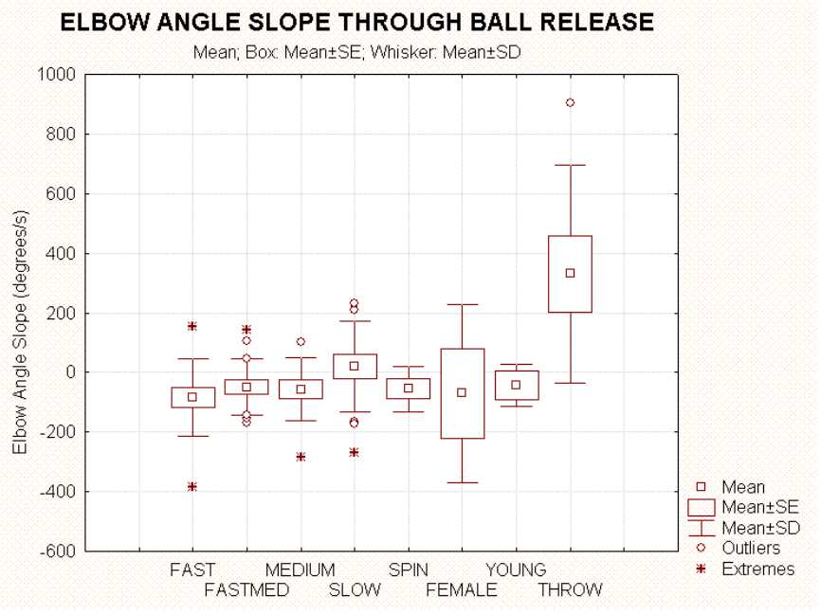
Figure 5: Mean elbow angle slope of bowling groups through release.

Throwers have positive elbow angle slopes: Practical Examples
There are distinct differences between bowling groups and the throwing group in their respective elbow angle excursion slopes through release. The bowlers either (i) flexed the elbow through release, (ii) maintained the elbow angle through release, or (iii) had a small elbow extension angle through release, which increased at less than 150º/s. From the green spike (bowling arm at shoulder height) to ball release (second black spike), one of New Zealand’s fastest bowlers has a small negative elbow angle excursion slope, which is a strong indicator of bowling legality (Figure 6). Interestingly, the elbow angle data presented in a report to the ICC on Muttiah Muralitharan’s bowling action by Elliott et al. (2004) show a negative excursion slope prior to release providing further evidence that Muralitharan is bowling legally. Note that this principle is only valid for the calculation of elbow angle about the flexion-extension axis in the JCS. The elbow segment angle calculation is not as accurate an indicator of bowling legality, and the elbow segment angle slope may be opposite to the elbow angle slope calculated in the JCS. Outdoor video measurements may not be able to accurately differentiate between elbow segment angle and elbow angle in the JCS. Hence, they may tend to show more bowlers extending through release than in the laboratory.
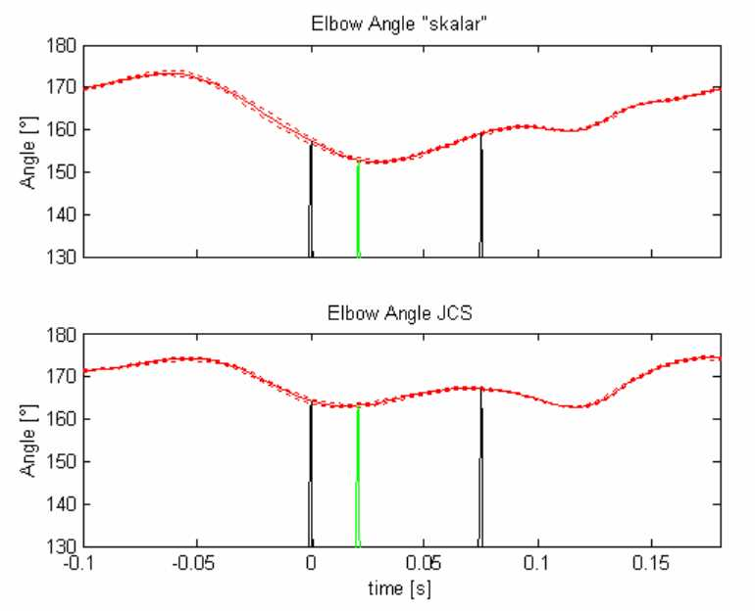
Figure 6: Elbow angle profile of a legal fast bowler: there is a small increase in elbow flexion through release when calculated in JCS. The elbow segment angle shows a slight increase through release, and should not be used to determine bowling action legality. (Top) Segment angle between upper arm and forearm. (Bottom) Elbow angle about flexion-extension axis in JCS. First black spike represents front foot contact, green spike occurs when the bowling arm has reached shoulder height, and the second spike occurs at ball release.
Illegal bowlers tend to extend the elbow through ball release, and therefore generate a positive elbow angle excursion slope of greater than 150º/s (Figure 7). In these cases both the segment angle and JCS elbow angle have positive slopes, but the segment angle excursion slope is greater. It is only at some point after release that the thrower begins to flex the elbow.
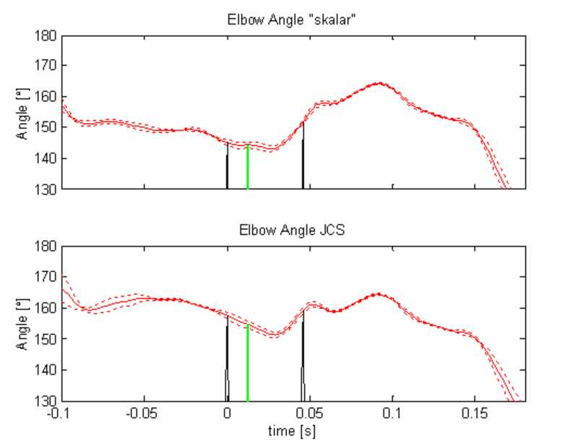
Figure 7: Elbow angle profile of a fast-medium ‘thrower’: there is a rapid increase in elbow angle straightening through release (> 150º/s). (Top) Segment angle between upper arm and forearm; (Bottom) Elbow angle about flexion-extension axis in JCS. First black spike represents front foot contact, green spike occurs when the bowling arm has reached shoulder height, and the second spike occurs at ball release.
Elbow angle excursion slope does not predictably correlate with elbow angle extension. Most correlations were weak, but they can be negative or positive (Figure 8). Also, the elbow extension angles of Throwers 1, 4, 5 and 6 are 15º or less, which would classify these bowlers as legal under a bowling law that only considers elbow extension. The most striking example of how throwing is not adequately defined under this law is demonstrated by Thrower 1. He registers the largest positive elbow angle excursion slope of all the subjects (953.4º/s) with only 12.6º of elbow extension. The real question is whether cricket should legalise such bowling actions (Video 1).
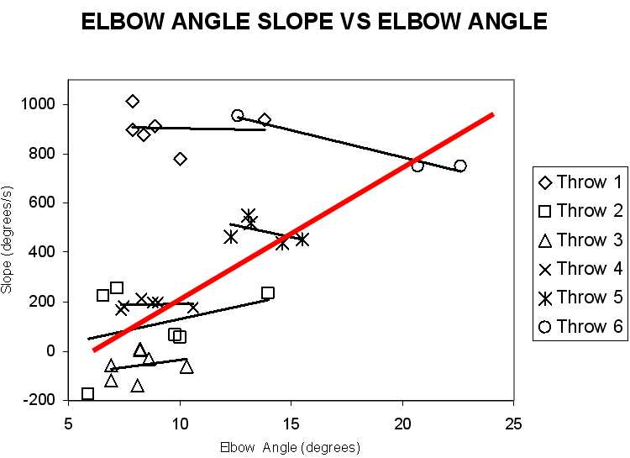
Figure 8: Elbow angle excursion slope versus elbow extension angle for 6 subjects in the Throw group. (R2 values: Thrower 1, 0.00; Thrower 2, 0.13; Thrower 3, 0.06; Thrower 4, 0.01; Thrower 5, 0.6; Thrower 6, 0.97). R2 for the Throw group is only 0.19 (red line).

Animations of Thrower 6, who had an elbow angle excursion slope of 953.4º with only 12.6º elbow extension, which is well within the limits of most bowlers.

Throwers have an advantage: Marshall and Ferdinands (2003) study
Bob Marshall (EIT, Hawkes Bay) is one of New Zealand’s elite biomechanists, and he hypothesised that bowlers who can maintain a fixed elbow flexion during delivery could use humerus internal rotation to produce higher ball release speeds. The qualitative basis of this theory was established in Marshall and Ferdinands (2003) by using a simple two-link model of the upper arm and forearm to calculate the change in wrist speed as (i) a function of effective lever length, and (ii) the wrist distance from the internal rotation axis of the humerus (Figure 10). The model predicted that the generation of wrist speed via humerus internal rotation is greater than any loss of wrist speed due to reduction in effective bowling arm length. The conclusion was that bowlers who could maintain a flexed arm through delivery either consciously or due to an elbow abnormality either of the fixed flexion or carry angle type had the potential to achieve substantially higher wrist speeds through the use of humerus internal rotation.
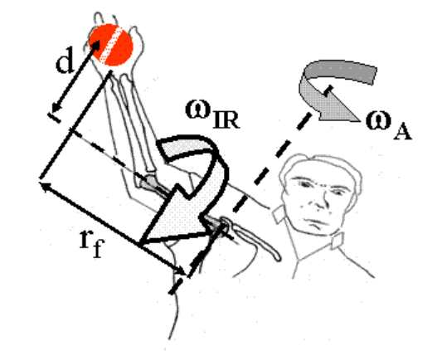
Figure 9: The longer the distance the ball is carried away from the long axis of the humerus, the higher the potential for humerus internal rotation to contribute to ball release speed. [Picture from Marshall and Ferdinands (2003)]
This study showed that a bowler such as Muttiah Muralitharan with a fixed flexion and carry angle deformity has the potential to legally utilise humerus internal rotation to generate speed and spin. This effect may be utilised legally to some extent by those bowlers who flex the bowling arm slightly through ball release. However, the most natural and probably most efficient method to use humerus internal rotation to generate ball speed is to extend at the elbow through release as in throwing. In throwing both elbow extension and humerus internal rotation are utilised to generate ball speed. The elbow angle profile of the animated delivery of Thrower 6 shows an elbow that is flexed initially up to 63º and then extends through release. This action has the properties of a throw despite the bowler only having an elbow extension of 12.6º from shoulder height to ball release. Under any proposed bowling law that only stipulates an elbow extension limit of 15º, this delivery would be perfectly legal. Such an action has the potential to generate higher ball speeds than the conventional bowling action, and does not have the mechanical characteristics of bowling.
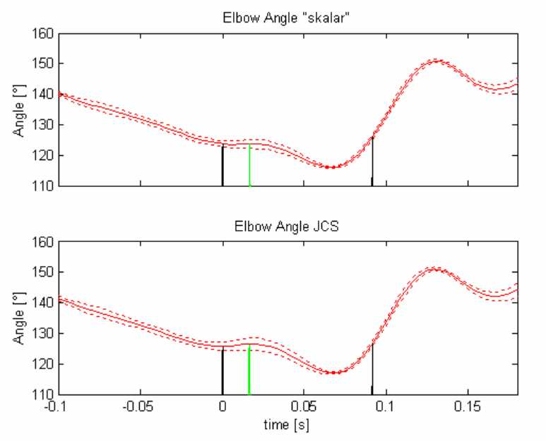
Figure 10: The elbow extension angle profile the bowler in the animation.

The future bowling law
For those bowlers who make up the vast majority of the bowling population and do not have fixed flexion or carry angle deformities, humerus internal rotation does not make a significant velocity contribution to ball speed. It is difficult to consciously bowl at speed with a bent arm without having significant rate of elbow extension through release. The data shows that it is possible to have an elbow extension angle from shoulder height to ball release less than 15º, and still generate a high positive elbow angle extension excursion slope. This fits the biomechanical criteria of a partial throw. Therefore, a law based only on elbow extension angle is not sufficient to prevent throwing in cricket.
This study suggests that a new bowling law should impose limits on the allowable elbow angle excursion slope during delivery. Such a constraint would prevent bowlers from using the same mechanisms utilised in throwing to generate ball speed – namely, humerus internal rotation and elbow extension. In light of these factors, elbow angle excursion slope is the most important determinant of bowling legality. A new bowling law may consider this property alone with no imposed constraint on elbow extension. This would be a departure from the current biomechanical approach, but in the sample tested there was not one bowler who exceeded 15º and still had a negative excursion slope, but there were several examples where the opposite was true. Also, from a mechanical point of view it may be impossible or inefficient to bend the elbow more than a certain amount if the end objective is to maintain or flex the elbow through ball release. For instance, the effect of humerus internal rotation would be nullified. However, from a psychological point of view there may be some benefit in adding an elbow extension angle constraint as well. This may prevent bowlers from thinking that they can get away with throwing. Also, it would promote the idea according to the traditional aesthetics of the game that bowling is essentially a straight arm motion. Further, it is recommended that the 15º limit be a preliminary measure until more laboratory testing of bowlers is performed worldwide to collaborate this study. Outdoor video testing may produce slightly higher elbow angles measurements than in the laboratory. It may be found that a flat tolerance level of elbow angle of 14º may be more appropriate under strict laboratory testing conditions, particularly if there is no consideration of elbow excursion slope.
The other advantage is that the concept of elbow angle excursion slope can allow extra tolerance for bowlers with elbow deformities. For instance, if it has been clinically established that a bowler has a hyperextension abnormality of the elbow then the elbow extension angle criteria could be waived, and the bowler only need conform to the elbow angle excursion slope limit. This may be a fair solution for all as it accommodates and acknowledges the presence of elbow abnormalities, but still imposes a well-defined constraint. Finally, more work needs to be performed to validate a formal excursion angle limit. This will require the co-operation of biomechanical researchers worldwide, and an agreement on universal testing protocols. Also, it is strongly recommended that this research is conducted only in accredited biomechanics laboratories. In field and outdoor video motion analysis should be reserved for approximate qualitative measures until its level of accuracy is compatible with that of the laboratory.
NOTE: All MCC cricket laws in this article were accessed from The Association of Cricket Statisticians & Historians. The laws of cricket.
http://www.cricinfo.com/db/SOCIETIES/ENG/ACS/CRICKET_HISTORY/LAWS/index.html (Accessed February 2005)

References
- Buchanan, J. (Ed.). 1972. Cricket’s greatest headlines. Project Publishing Pty. Limited, N.S.W., pp. 112-114.
- Elliott, B.C., Alderson, J., Reid, S. And Foster, D. 2004. Bowling report of Muttiah Muralitharan.
- Ferdinands, R.E.D. 2004. Three-dimensional biomechanical analysis of bowling in cricket. PhD Thesis, University of Waikato.
- Ferdinands, R.E.D., and Kersting, U.G. (2004). Elbow Angle Extension and implications for the legality of the bowling action in Cricket. In A. McIntosh (Ed.), Proceedings of Australasian Biomechanics Conference 5 (December 9-10), University of New South Wales, Sydney, pp. 26-27
- Goonetilleke, R.S. 1999. Legality of bowling actions in cricket. Ergonomics, 42 (10), 1386-1397.
- Grood, E.S. and Suntay, W.J. (1983). A joint coordinate system for the clinical description of three-dimensional motions: application to the knee. Journal of Biomechanical Engineering, 105, 136-144.
- Lloyd, D.G., Alderson, J. and Elliott, B.C. 2000. An upper limb kinematic model for the examination of cricket bowling: A case study of Muttiah Muralitharan. Journal of Sports Sciences, 18, 975-982.
- Marshall, R. and Ferdinands, R. (2003). The effect of a flexed elbow on bowling speed in cricket. Sports Biomechanics, 2(1), 65-71.
- Portus, M., Mason, B., Rath, D. and Rosemond, C. (2003). Fast bowling arm actions and the illegal delivery law in men’s high performance cricket matches. Science and Medicine in Cricket. R. Stretch, T. Noakes and C. Vaughan (Eds.), Com Press, Port Elizabeth, South Africa, pp. 41-54.
- The Association of Cricket Statisticians & Historians. The laws of cricket. http://www.cricinfo.com/db/SOCIETIES/ENG/ACS/CRICKET_HISTORY/LAWS/index.html (Accessed February 2005)

